**Assignment-6 Data Structure and Integration in Program**

**Subject: CSW2 (CSE 2141)**

**Name: Arpit Kumar Mohanty**

**Registration Number: 2341013237**

**Section: 23412G1**

**Branch: CSE**

**Q1. Design a class BSTNode in Java with a member variable info to store an integer and two references, left and right, to represent its left and right children. Implement a constructor to initialize these attributes. Develop a method to insert a node while maintaining the properties of a binary search tree. Extend this implementation by adding methods for traversing the tree using pre-order, in-order, and post-order techniques. Finally, add a main method to create a binary search tree, insert multiple nodes, and invoke the traversal methods to display the tree structure.  
  
Solution: 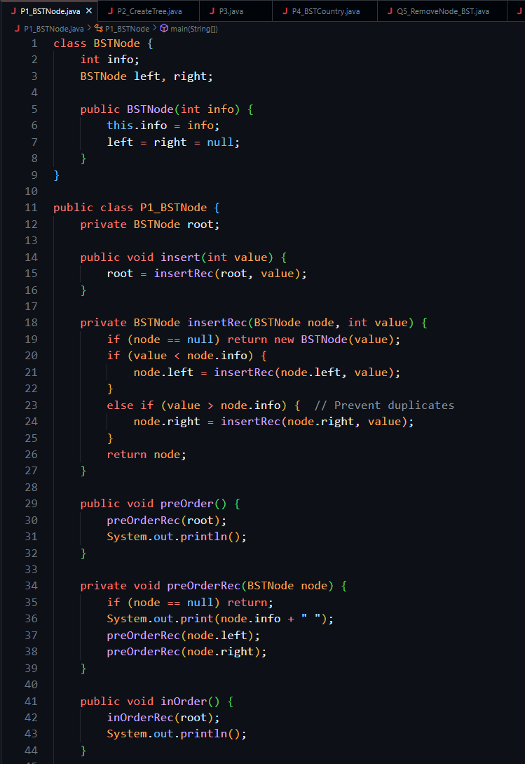  
  
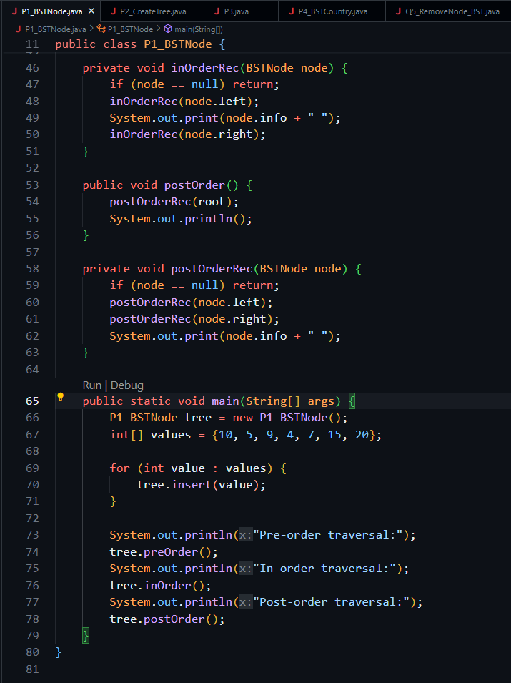  
  
Output: 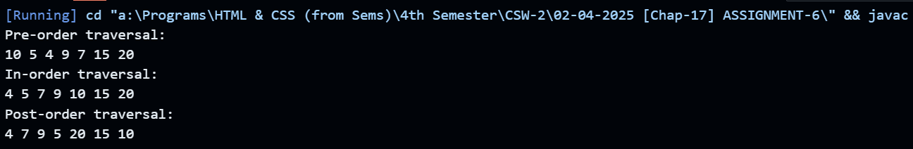  
  
Q2. Construct a binary search tree from the given array of elements: {10, 20, 30, 40, 50, 60, 70, 80, 90, 100}. Include a method called CreateTree to construct the binary search tree from a sorted array. This method takes an array of integers as input and constructs the tree recursively using a binary search algorithm.  
  
Solution: 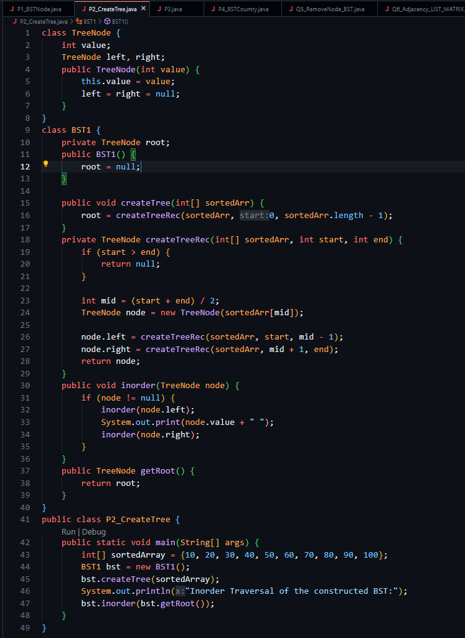  
  
Output: 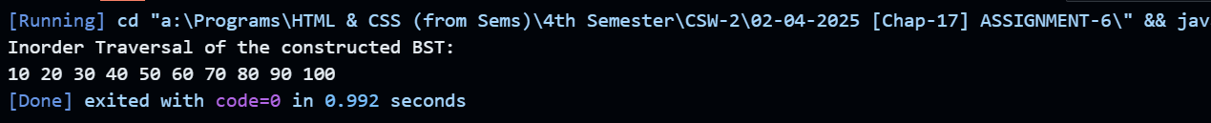  
  
Q3. Determine if a given binary tree is a binary search tree. You will use an isBST method, which takes the maximum and minimum range of the values of the nodes.  
  
Solution: 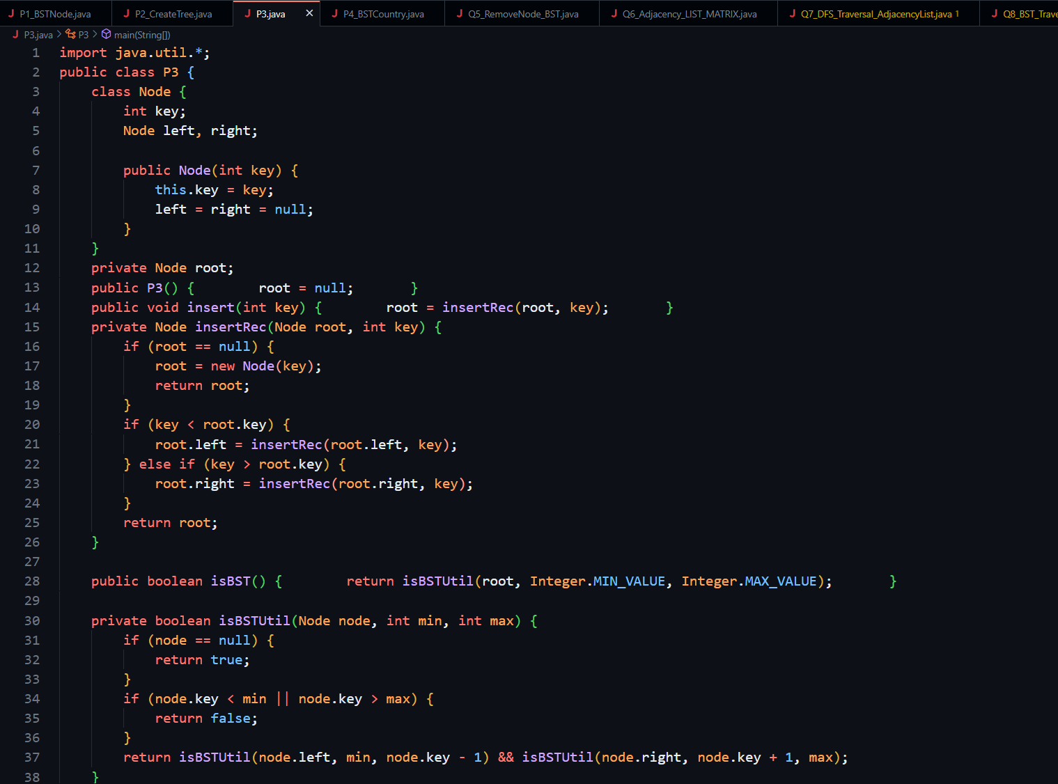  
  
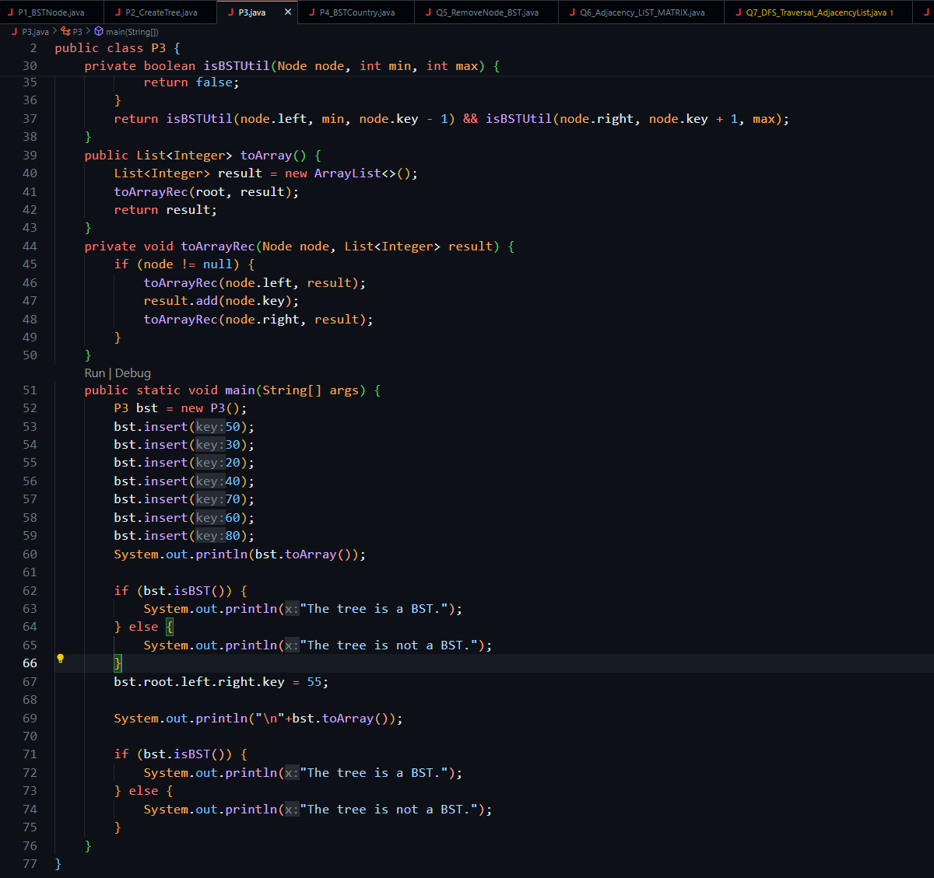  
  
Output: 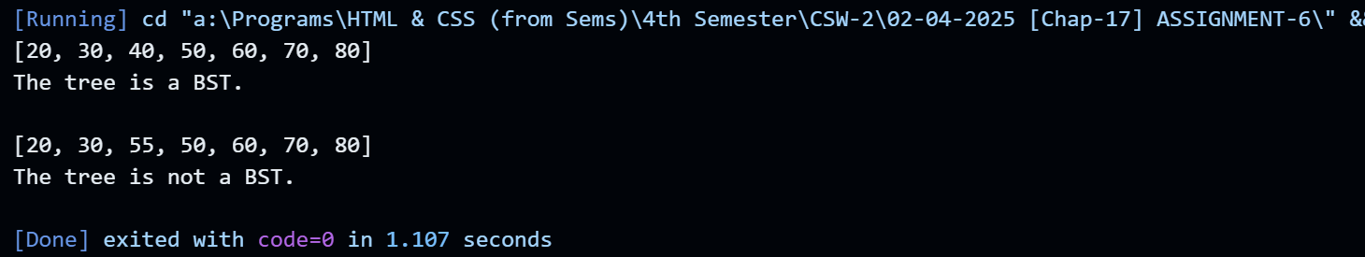  
  
Q4. Design a Java program to manage country data using a binary search tree (BST). Create a class Country with members for name and population, along with a constructor and necessary methods. Define a class BNode to store a Country object and maintain references to its left and right children. Implement a class BSTCountry with a root node, a constructor, and a method to insert countries into the tree based on their population. Extend the BST by adding methods for in-order traversal, finding the country with the maximum population (findMax), and finding the country with the minimum population (findMin). Finally, develop a main method to create a BST, insert country nodes, and invoke these methods to display the results.  
  
Solution: 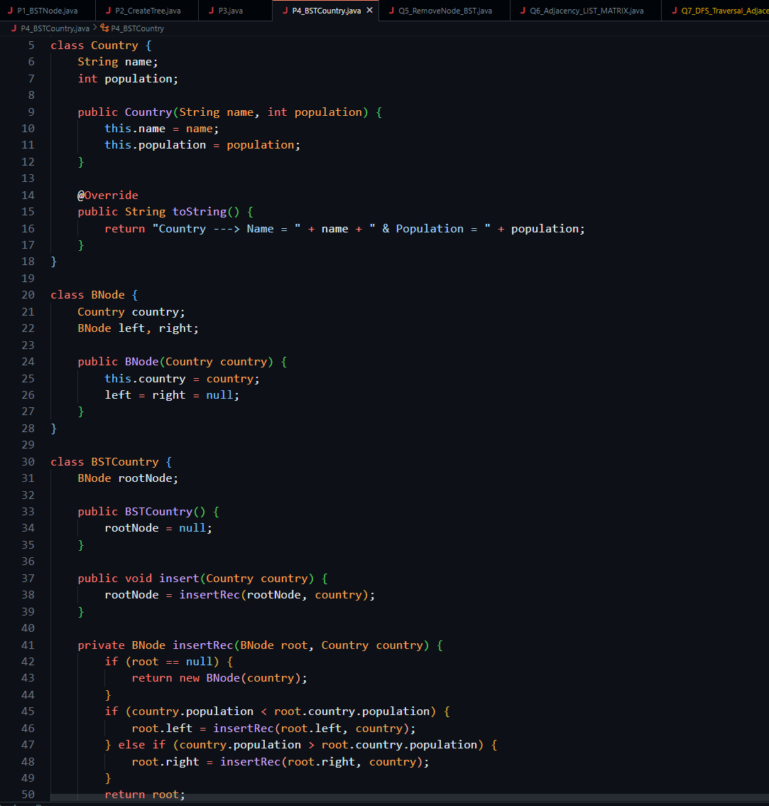  
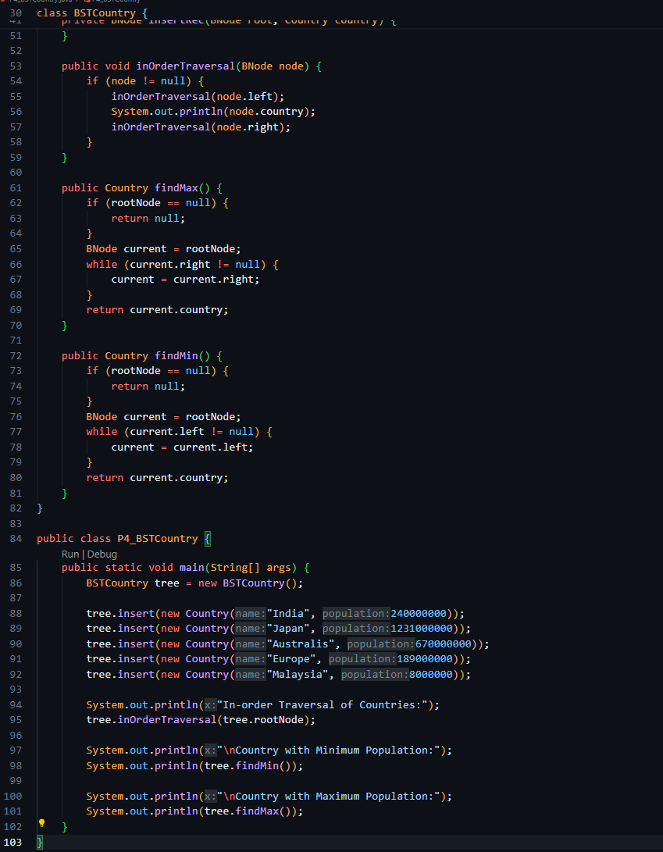  
Output: 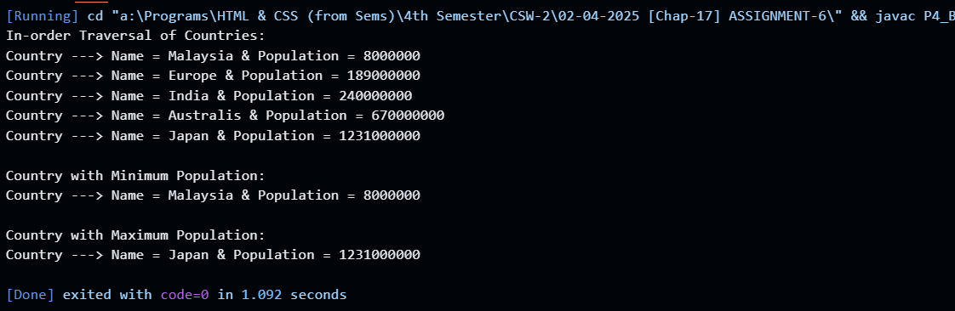  
  
Q5. Implement a method to remove node x from a binary search tree while ensuring that the tree maintains its properties. The deletion process involves three cases:**

**1. Case 1: Node x has no children (a leaf node).**

**2. Case 2: Node x has one child (either left or right).**

**3. Case 3: Node x has two children, requiring a suitable replacement to maintain the BST structure**

**Solution:** 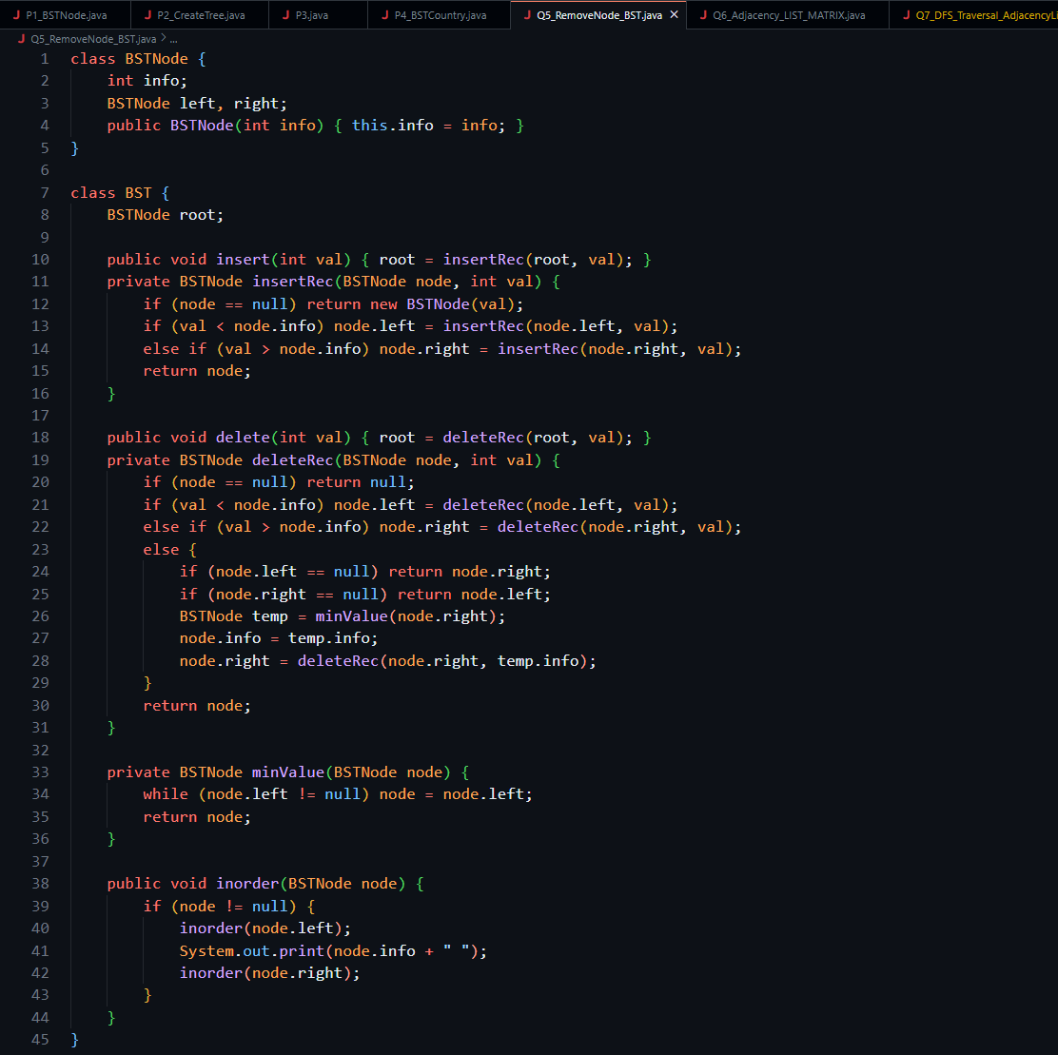

**Output: 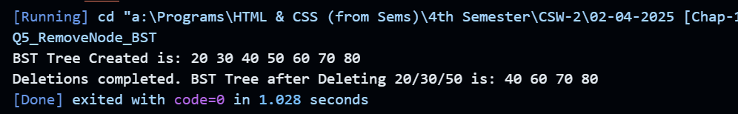  
  
Q6. Write a program to implement a graph using an adjacency matrix and adjacency list representation. Develop methods to construct the graph and display its adjacency matrix and adjacency list.  
  
Solution: 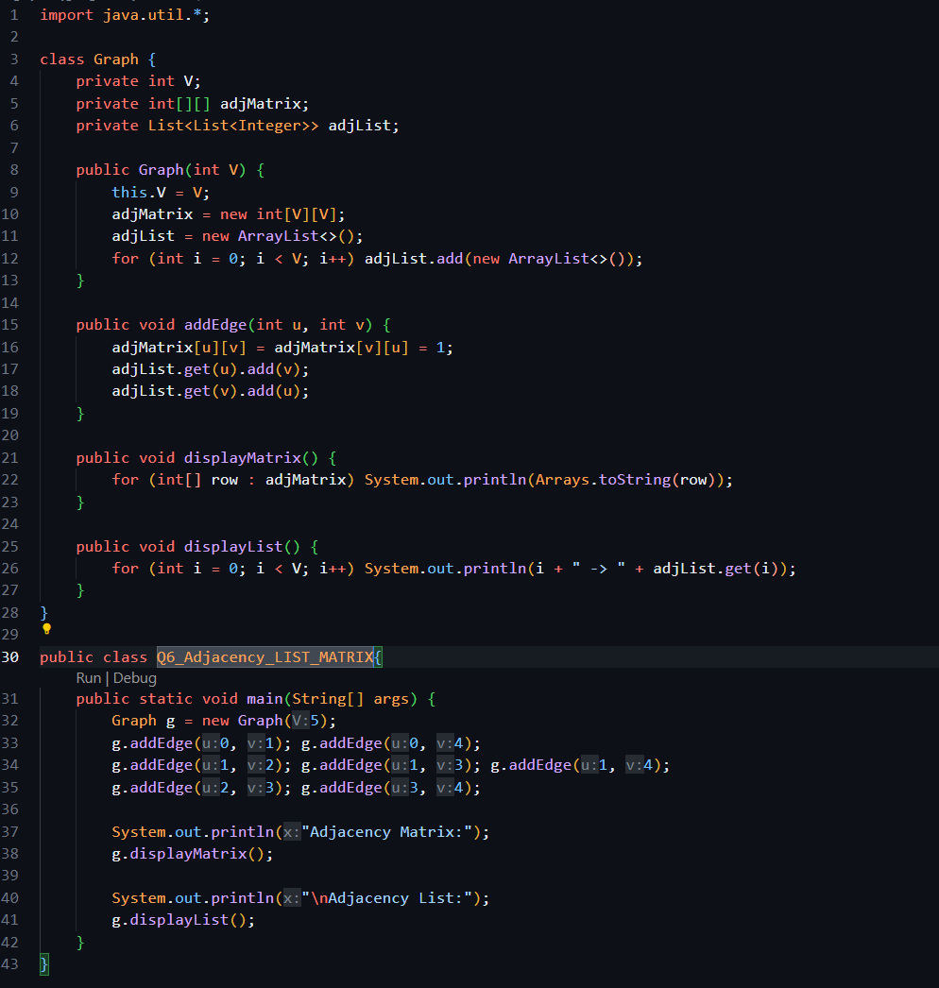  
  
Output: 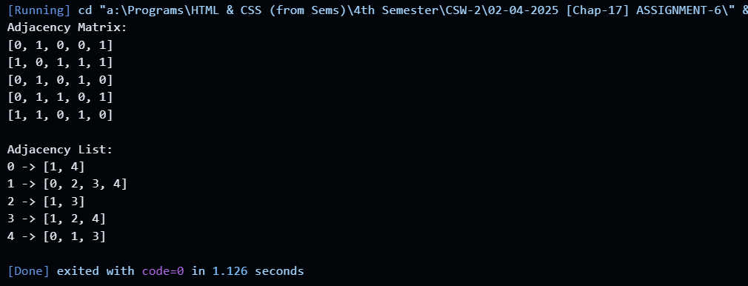  
  
Q7. Create a class Graph that uses a linked list to represent N vertices. Implement a constructor to initialize the graph. Add a method to read a graph and store it using an adjacency list representation. Additionally, implement a Depth-First Search (DFS) method to traverse the graph's vertices. Finally, include a main method to create a graph, invoke the implemented methods, and display the traversal results.  
  
Solution:** 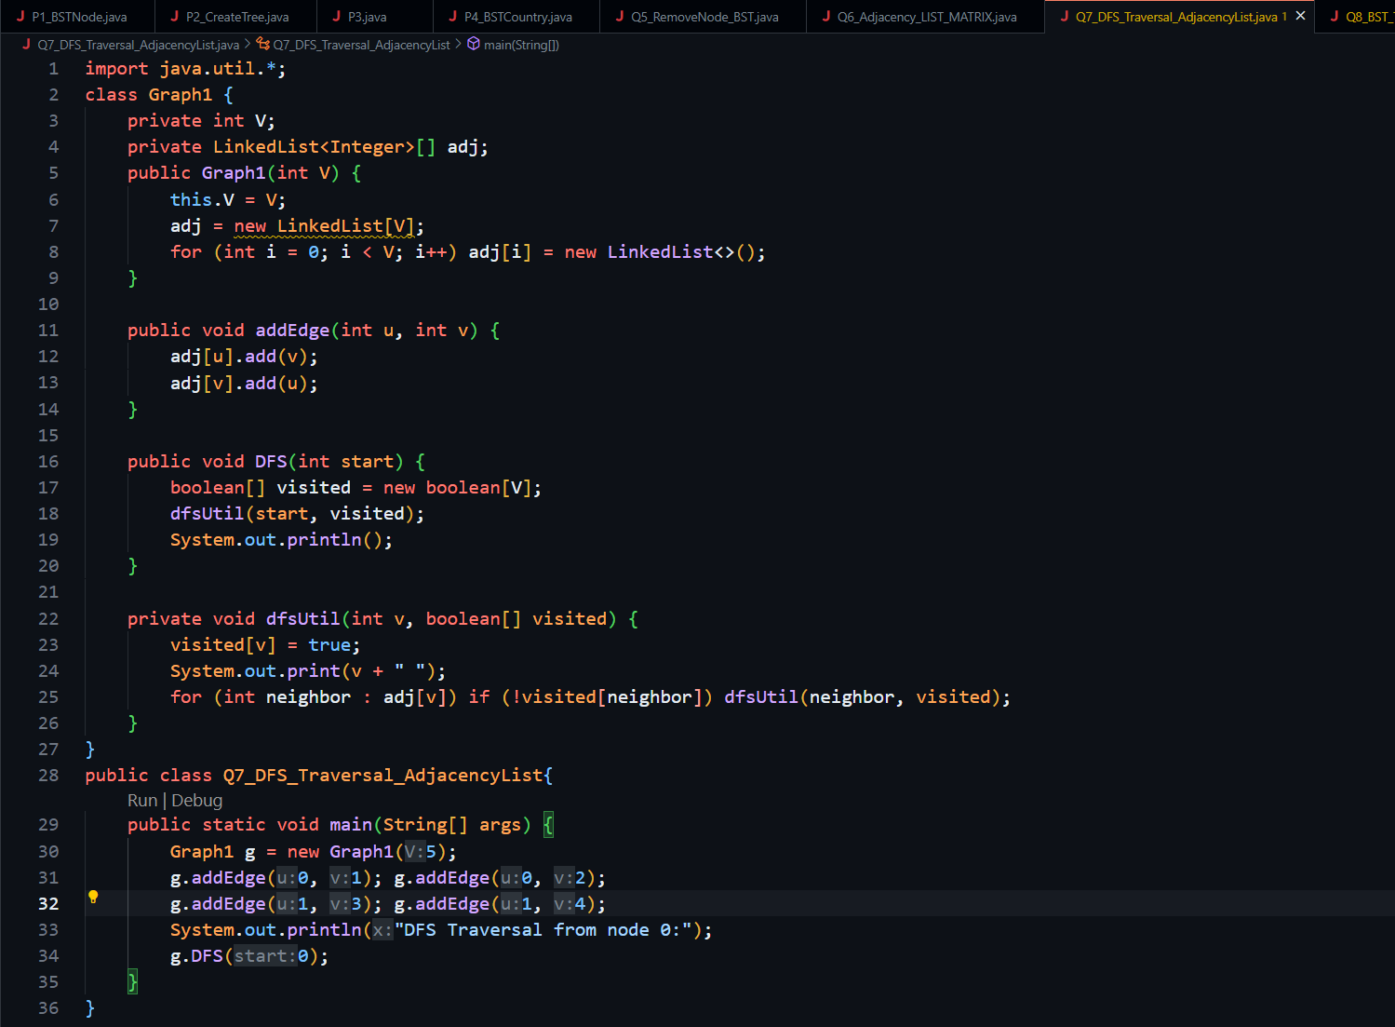

**Output: 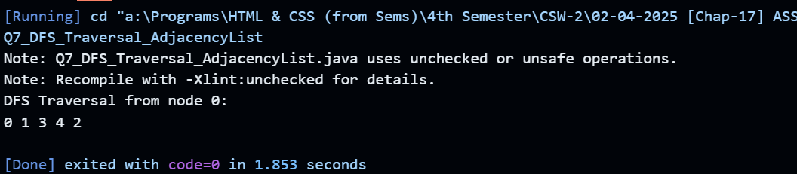  
  
Q8. Implement a Java program to traverse a graph using Breadth-First Search (BFS) with an adjacency list. Use ArrayDeque for efficient traversal. The program should include methods to initialize the graph, add edges, display the adjacency list, and perform BFS. Finally, use the main method to construct the graph, invoke BFS, and display the traversal output.  
  
Solution: 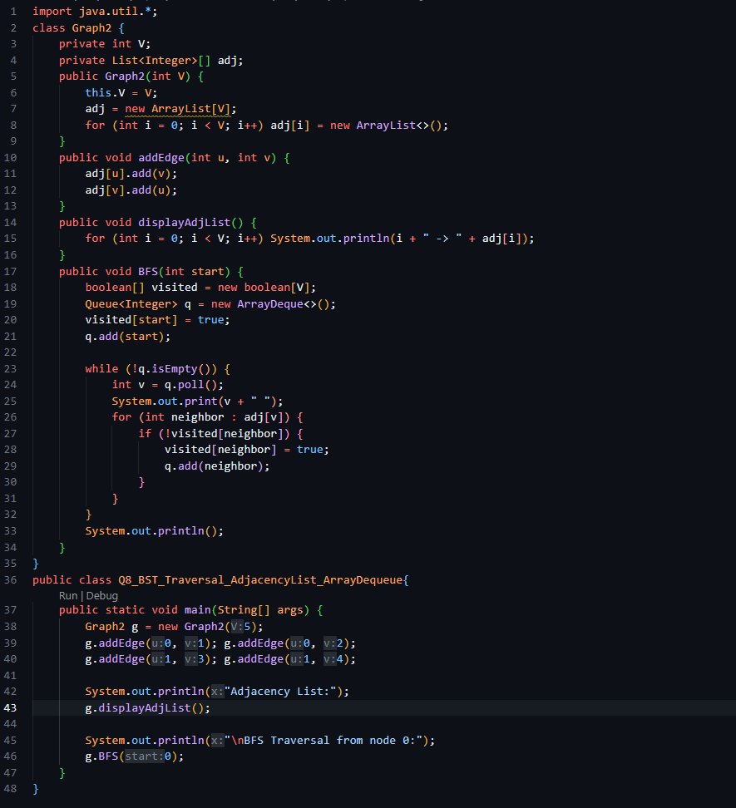  
Output:** 